Operating System Definition and Function

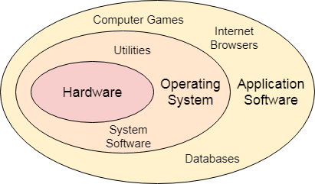

An **Operating System** can be defined as an **interface between user and hardware**. It is responsible for the execution of all the processes, Resource Allocation, CPU management, File Management and many other tasks.The purpose of an operating system is to provide an environment in which a user can execute programs in convenient and efficient manner.

**Types of Operating Systems (OS)**

An operating system is a well-organized collection of programs that manages the computer hardware. It is a type of system software that is responsible for the smooth functioning of the computer system.

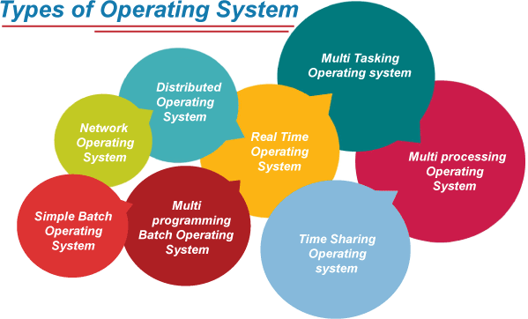

Batch Operating System

In the 1970s, Batch processing was very popular. In this technique, similar types of jobs were batched together and executed in time. People were used to having a single computer which was called a mainframe.

In Batch operating system, access is given to more than one person; they submit their respective jobs to the system for the execution.

The system put all of the jobs in a queue on the basis of first come first serve and then executes the jobs one by one. The users collect their respective output when all the jobs get executed.

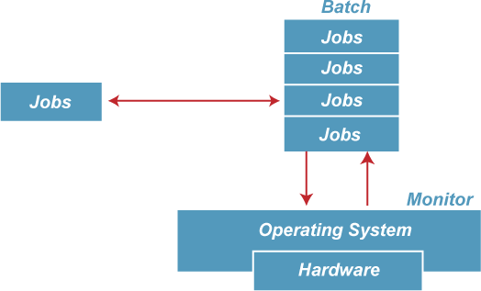

The purpose of this operating system was mainly to transfer control from one job to another as soon as the job was completed. It contained a small set of programs called the resident monitor that always resided in one part of the main memory. The remaining part is used for servicing jobs.

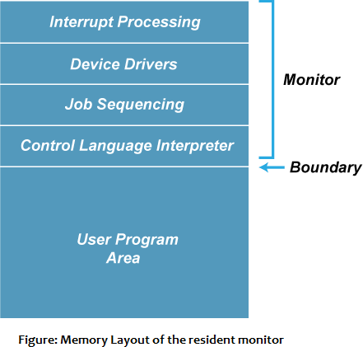

Advantages of Batch OS

* The use of a resident monitor improves computer efficiency as it eliminates CPU time between two jobs.

Disadvantages of Batch OS

# Starvation

Batch processing suffers from starvation.

# For Example:

There are five jobs J1, J2, J3, J4, and J5, present in the batch. If the execution time of J1 is very high, then the other four jobs will never be executed, or they will have to wait for a very long time. Hence the other processes get starved.

# Not Interactive

Batch Processing is not suitable for jobs that are dependent on the user's input. If a job requires the input of two numbers from the console, then it will never get it in the batch processing scenario since the user is not present at the time of execution.

Multiprogramming Operating System

Multiprogramming is an extension to batch processing where the CPU is always kept busy. Each process needs two types of system time: CPU time and IO time.

In a multiprogramming environment, when a process does its I/O, The CPU can start the execution of other processes. Therefore, multiprogramming improves the efficiency of the system.

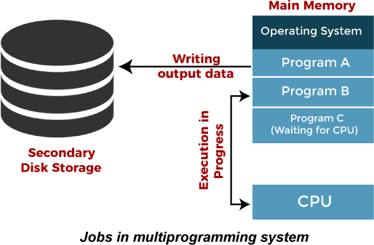

Advantages of Multiprogramming OS

* + Throughout the system, it increased as the CPU always had one program to execute.
  + Response time can also be reduced.

Disadvantages of Multiprogramming OS

* + Multiprogramming systems provide an environment in which various systems resources are used efficiently, but they do not provide any user interaction with the computer system.

Multiprocessing Operating System

In Multiprocessing, Parallel computing is achieved. There are more than one processors present in the system which can execute more than one process at the same time. This will increase the throughput of the system.

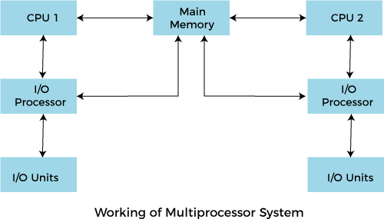

In Multiprocessing, Parallel computing is achieved. More than one processor present in the system can execute more than one process simultaneously, which will increase the throughput of the system.

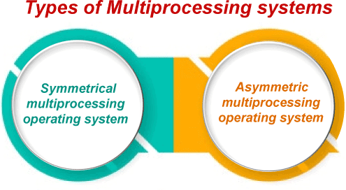

Advantages of Multiprocessing operating system:

* + **Increased reliability:** Due to the multiprocessing system, processing tasks can be distributed among several processors. This increases reliability as if one processor fails, the task can be given to another processor for completion.
  + **Increased throughout:** As several processors increase, more work can be done in less.

Disadvantages of Multiprocessing operating System

* + Multiprocessing operating system is more complex and sophisticated as it takes care of multiple CPUs simultaneously.

Multitasking Operating System

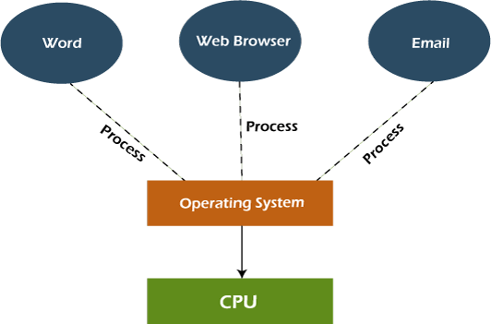

The multitasking operating system is a logical extension of a multiprogramming system that enables **multiple** programs simultaneously. It allows a user to perform more than one computer task at the same time.

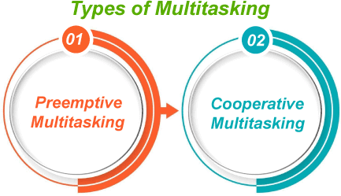

Advantages of Multitasking operating system

* + This operating system is more suited to supporting multiple users simultaneously.
  + The multitasking operating systems have well-defined memory management.

Disadvantages of Multitasking operating system

* + The multiple processors are busier at the same time to complete any task in a multitasking environment, so the CPU generates more heat.

Network Operating System

An Operating system, which includes software and associated protocols to communicate with other computers via a network conveniently and cost-effectively, is called Network Operating System.

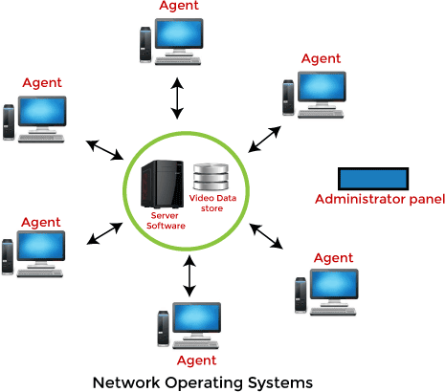

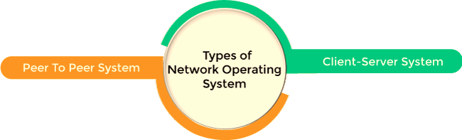

Advantages of Network Operating System

* + In this type of operating system, network traffic reduces due to the division between clients and the server.
  + This type of system is less expensive to set up and maintain.

Disadvantages of Network Operating System

* + In this type of operating system, the failure of any node in a system affects the whole system.
  + Security and performance are important issues. So trained network administrators are required for network administration.

Real Time Operating System

In Real-Time Systems, each job carries a certain deadline within which the job is supposed to be completed, otherwise, the huge loss will be there, or even if the result is produced, it will be completely useless.

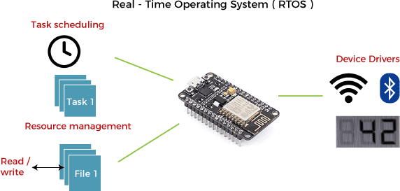

The Application of a Real-Time system exists in the case of military applications, if you want to drop a missile, then the missile is supposed to be dropped with a certain precision.

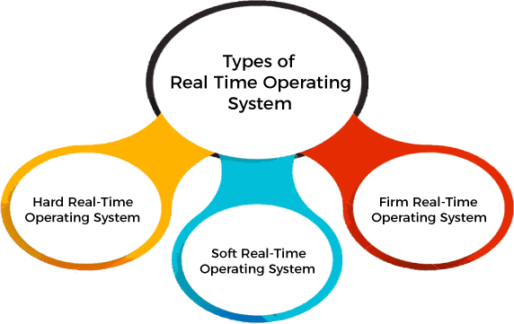

Advantages of Real-time operating system:

* + Easy to layout, develop and execute real-time applications under the real-time operating system.
  + In a Real-time operating system, the maximum utilization of devices and systems.

Disadvantages of Real-time operating system:

* + Real-time operating systems are very costly to develop.
  + Real-time operating systems are very complex and can consume critical CPU cycles.

Time-Sharing Operating System

In the Time Sharing operating system, computer resources are allocated in a time-dependent fashion to several programs simultaneously. Thus it helps to provide a large number of user's direct access to the main computer. It is a logical extension of multiprogramming. In time-sharing, the CPU is switched among multiple programs given by different users on a scheduled basis.

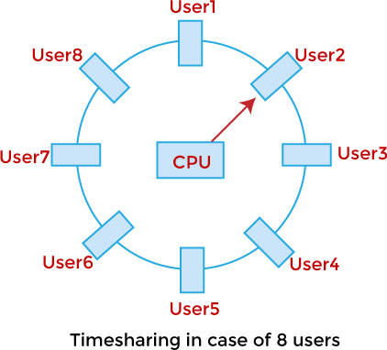

Advertisement

A time-sharing operating system allows many users to be served simultaneously, so sophisticated CPU scheduling schemes and Input/output management are required.

Time-sharing operating systems are very difficult and expensive to build.

Advantages of Time Sharing Operating System

* + The time-sharing operating system provides effective utilization and sharing of resources.
  + This system reduces CPU idle and response time.

Disadvantages of Time Sharing Operating System

* + Data transmission rates are very high in comparison to other methods.
  + Security and integrity of user programs loaded in memory and data need to be maintained as many users access the system at the same time.

Distributed Operating System

The Distributed Operating system is not installed on a single machine, it is divided into parts, and these parts are loaded on different machines. A part of the distributed Operating system is installed on each machine to make their communication possible. Distributed Operating systems are much more complex,

large, and sophisticated than Network operating systems because they also have to take care of varying networking protocols.

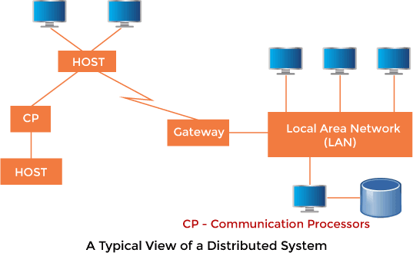

Advantages of Distributed Operating System

* + The distributed operating system provides sharing of resources.
  + This type of system is fault-tolerant.

Disadvantages of Distributed Operating System

* + Protocol overhead can dominate computation cost.

**FUNCTIONS OF OS**

# The operating system provides various functionalities, which are discussed below: Controlling System Performance

One of the most important functions of the operating system is controlling the system's health. For this purpose, it monitors and observes the delay time between a service being requested and the requested service being served. This delay time is reduced as much as possible to improve the overall performance of the system.

# Memory Management

In a computer system, we have primary memory, which is also called main memory, and it is made by the sequence of bytes. Each byte in the main memory has a unique address which helps it to check if it is occupied or not. For executing each program in its computer system, it should be in the main memory. Operating systems can easily check which bytes of main memory are empty and which are not. So it allocates the main memory for the program execution, and when the program is completed or terminated, then it deallocates the memory. Operating systems also keep a record that which byte of memory is assigned to which program.

# Device Management

The operating system manages the communication between the computer system and the peripheral devices connected to the I/O port of the system. Peripheral devices use their respective drivers to communicate with the system. The operating system determines which program or process is accessed by which connection and device. It also makes sure when a program is executed or terminated, it will stop the communication between the device and the computer system.

# Coordination between other software and the user

There is other software in the system which is coordinated by the operating system so that users can access them efficiently, like assemblers, compilers, etc.

Advertisement

# Process Management

The process is a program under the execution. The operating system manages all the processes so that each process gets the CPU for a specific time to execute itself, and there will be less waiting time for each process. This management is also called process scheduling.

For process scheduling operating system uses various algorithms:

* + **First Come First Serve (FCFS) Algorithm**: In this algorithm, which comes first is served first by the CPU until it is completed. It is a non-preemptive algorithm which means it cannot be terminated without completing it.
  + **Shortest Job First (SJF) Algorithm:** The process which has the shortest burst time (execution time) that will be served first by the CPU.
  + **Longest Job First (LJF) Algorithm:** This algorithm is based on the phenomenon that the process that has the longest execution time will be served first by the processor.
  + **Round Robin Algorithm:** In this algorithm, there is a specific time quanta assigned for each process. If the process is not executed in time quanta, it is sent to the waiting queue for its next turn.
  + **Priority Scheduling Algorithm:** Processes are given the priority based on different criteria and scheduled according to the highest priority. Criteria can be burst time or arrival time etc.

# Resource Allocation

The operating system manages all the resources of the computer system. It ensures the use of all the resources by managing which resource is used by which process and for how much time.

# Information and Resource Protection

All the data and information available on the machine are protected by the operating system. If any external resource tries to attack the computer resource and steal the data, then the operating system helps to prevent the attack.

Advertisement

# Handling the I/O Operations

Input/output devices like mouse, keyboards, printers etc., are external I/O devices, and there are different natures of each device. The operating system appropriately manages the input and output operation of these devices.

# Job Priority:

Advertisement

The work of job priority is creation and promotion. It determines what action should be done first in a computer system.

# Special Control Program:

Advertisement

The operating systems make automatic changes to the task through specific control programs. These programs are called Special Control Program.

# Scheduling of resources and jobs:

The operating system prepares the list of tasks to be performed for the device of the computer system. The operating system decides which device to use for which task. This action becomes complicated when multiple tasks are to be performed simultaneously in a computer system. The scheduling programs of the operating system determine the order in which tasks are completed. It performs these tasks based on the priority of performing the tasks given by the user. It makes the tasks available based on the priority of the device.

# Security:

Computer security is a very important aspect of any operating system. The reliability of an operating system is determined by how much better security it provides us. Modern operating systems use a firewall for security. A firewall is a security system that monitors every activity happening in the computer and blocks that activity in case of any threat.

# Monitoring activities:

Advertisement

The operating system takes care of the activities of the computer system during various processes. This aborts the program if there are errors. The operating system sends instant messages to the user for any unexpected error in the input/output device. It also provides security to the system when the operating system is used in systems operated by multiple users. So that illegal users cannot get data from the system.

# Job accounting:

It keeps track of time & resources used by various jobs and users.

**Operating System Structure**

Overview

An operating system is a design that enables user application programs to communicate with the hardware of the machine. The operating system should be built with the utmost care because it is such a complicated structure and should be simple to use and modify. Partially developing the operating system is a simple approach to accomplish this. Each of these components needs to have distinct inputs, outputs, and functionalities.

This article discusses many sorts of structures that implement operating systems, as listed below, as well as how and why they work. It also defines the operating system structure.

* + Simple Structure
  + Monolithic Structure
  + Layered Approach Structure
  + Micro-Kernel Structure
  + Exo-Kernel Structure
  + Virtual Machines

What is an operating System Structure?

We want a clear structure to let us apply an operating system to our particular needs because operating systems have complex structures. It is easier to create an operating system in pieces, much as we break down larger issues into smaller, more manageable subproblems. Every segment is also a part of the operating system. Operating system structure can be thought of as the strategy for connecting and incorporating various operating system components within the kernel. Operating systems are implemented using many types of structures, as will be discussed below:

SIMPLE STRUCTURE

*It is the most straightforward operating system structure, but it lacks definition and is only appropriate for usage with tiny and restricted systems. Since the interfaces and degrees of functionality in this structure are clearly defined, programs are able to access I/O routines, which may result in unauthorized access to I/O procedures.*

This organizational structure is used by the MS-DOS operating system:

* + There are four layers that make up the MS-DOS operating system, and each has its own set of features.
  + These layers include ROM BIOS device drivers, MS-DOS device drivers, application programs, and system programs.
  + The MS-DOS operating system benefits from layering because each level can be defined independently and, when necessary, can interact with one another.
  + If the system is built in layers, it will be simpler to design, manage, and update. Because of this, simple structures can be used to build constrained systems that are less complex.
  + When a user program fails, the operating system as whole crashes.
  + Because MS-DOS systems have a low level of abstraction, programs and I/O procedures are visible to end users, giving them the potential for unwanted access.

The following figure illustrates layering in simple structure:

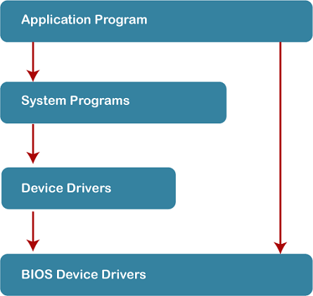

# Advantages of Simple Structure:

* + Because there are only a few interfaces and levels, it is simple to develop.
  + Because there are fewer layers between the hardware and the applications, it offers superior performance.

# Disadvantages of Simple Structure:

* + The entire operating system breaks if just one user program malfunctions.
  + Since the layers are interconnected, and in communication with one another, there is no abstraction or data hiding.
  + The operating system's operations are accessible to layers, which can result in data tampering and system failure.

MONOLITHIC STRUCTURE

*The monolithic operating system controls all aspects of the operating system's operation, including file management, memory management, device management, and operational operations.*

The core of an operating system for computers is called the kernel (OS). All other System components are provided with fundamental services by the kernel. The operating system and the hardware use it as their main interface. When an operating system is built into a single piece of hardware, such as a keyboard or mouse, the kernel can directly access all of its resources.

The monolithic operating system is often referred to as the monolithic kernel. Multiple programming techniques such as batch processing and time-sharing increase a processor's usability. Working on top of the operating system and under complete command of all hardware, the monolithic kernel performs the role of a virtual computer. This is an old operating system that was used in banks to carry out simple tasks like batch processing and time-sharing, which allows numerous users at different terminals to access the Operating System.

The following diagram represents the monolithic structure:

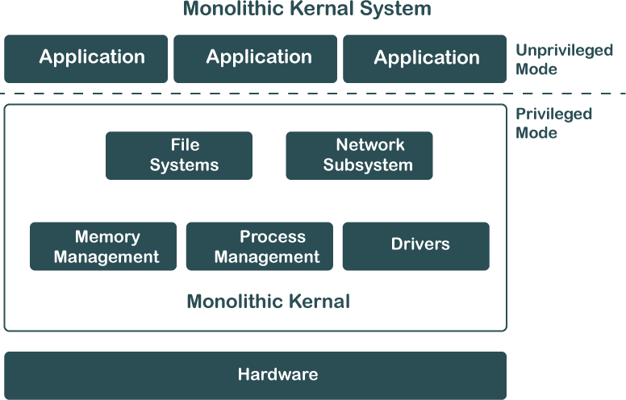

# Advantages of Monolithic Structure:

* + Because layering is unnecessary and the kernel alone is responsible for managing all operations, it is easy to design and execute.
  + Due to the fact that functions like memory management, file management, process scheduling, etc., are implemented in the same address area, the monolithic kernel runs rather quickly when compared to other systems. Utilizing the same address speeds up and reduces the time required for address allocation for new processes.

# Disadvantages of Monolithic Structure:

* + The monolithic kernel's services are interconnected in address space and have an impact on one another, so if any of them malfunctions, the entire system does as well.
  + It is not adaptable. Therefore, launching a new service is difficult.

LAYERED STRUCTURE

*The OS is separated into layers or levels in this kind of arrangement. Layer 0 (the lowest layer) contains the hardware, and layer 1 (the highest layer) contains the user interface (layer N). These layers are organized hierarchically, with the top-level layers making use of the capabilities of the lower-level ones.*

The functionalities of each layer are separated in this method, and abstraction is also an option. Because layered structures are hierarchical, debugging is simpler, therefore all lower-level layers are debugged before the upper layer is examined. As a result, the present layer alone has to be reviewed since all the lower layers have already been examined.

The image below shows how OS is organized into layers:

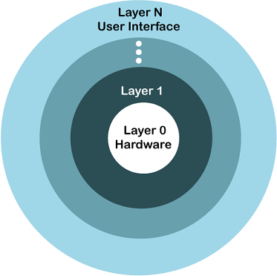

# Advantages of Layered Structure:

* + Work duties are separated since each layer has its own functionality, and there is some amount of abstraction.
  + Debugging is simpler because the lower layers are examined first, followed by the top layers.

# Disadvantages of Layered Structure:

* + Performance is compromised in layered structures due to layering.
  + Construction of the layers requires careful design because upper layers only make use of lower layers' capabilities.

MICRO-KERNEL STRUCTURE

*The operating system is created using a micro-kernel framework that strips the kernel of any unnecessary parts. Systems and user applications are used to implement these optional kernel components. So, Micro-Kernels is the name given to these systems that have been developed.*

Each Micro-Kernel is created separately and is kept apart from the others. As a result, the system is now more trustworthy and secure. If one Micro-Kernel malfunctions, the remaining operating system is unaffected and continues to function normally.

The image below shows Micro-Kernel Operating System Structure:

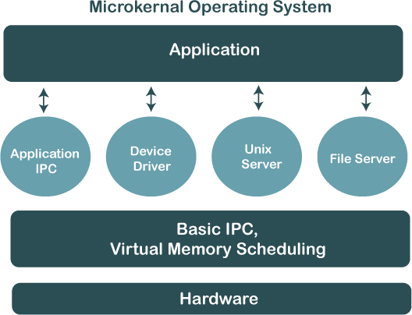

# Advantages of Micro-Kernel Structure:

* + It enables portability of the operating system across platforms.
  + Due to the isolation of each Micro-Kernel, it is reliable and secure.
  + The reduced size of Micro-Kernels allows for successful testing.
  + The remaining operating system remains unaffected and keeps running properly even if a component or Micro-Kernel fails.

# Disadvantages of Micro-Kernel Structure:

* + The performance of the system is decreased by increased inter-module communication.
  + The construction of a system is complicated.

EXOKERNEL

An operating system called Exokernel was created at MIT with the goal of offering application-level management of hardware resources. The exokernel architecture's goal is to enable application-specific customization by separating resource management from protection. Exokernel size tends to be minimal due to its limited operability.

Because the OS sits between the programs and the actual hardware, it will always have an effect on the functionality, performance, and breadth of the apps that are developed on it. By rejecting the idea that an operating system must offer abstractions upon which to base applications, the exokernel operating system makes an effort to solve this issue. The goal is to give developers as few restriction on the use of abstractions as possible while yet allowing them the freedom to do so when necessary. Because of the way the exokernel architecture is designed, a single tiny kernel is responsible for moving all hardware abstractions into unreliable libraries known as library operating systems. Exokernels differ from micro- and monolithic kernels in that their primary objective is to prevent forced abstraction.

# Exokernel operating systems have a number of features, including:

* + Enhanced application control support.
  + Splits management and security apart.
  + A secure transfer of abstractions is made to an unreliable library operating system.
  + Brings up a low-level interface.
  + Operating systems for libraries provide compatibility and portability.

# Advantages of Exokernel Structure:

* + Application performance is enhanced by it.
  + Accurate resource allocation and revocation enable more effective utilisation of hardware resources.
  + New operating systems can be tested and developed more easily.
  + Every user-space program is permitted to utilise its own customised memory management.

# Disadvantages of Exokernel Structure:

* + A decline in consistency
  + Exokernel interfaces have a complex architecture.

**Generation of Operating System**

Below are four generations of operating systems.

* The First Generation
* The Second Generation
* The Third Generation
* The Fourth Generation

# The First Generation (1940 to early 1950s)

In 1940, an operating system was not included in the creation of the first electrical computer. Early computer users had complete control over the device and wrote programs in pure machine language for every task. During the computer generation, a programmer can merely execute and solve basic mathematical calculations. an operating system is not needed for these computations.

# The Second Generation (1955 – 1965)

GMOSIS, the first operating system (OS) was developed in the early 1950s. For the IBM Computer, General Motors has created the operating system. Because it gathers all related jobs into groups or batches and then submits them to the operating system using a punch card to finish all of them, the second-generation operating system was built on a single-stream batch processing system.

# The Third Generation (1965 – 1980)

Because it gathers all similar jobs into groups or batches and then submits them to the second generation operating system using a punch card to finish all jobs in a machine, the second-generation operating system was based on a single stream batch processing system. Control is transferred to the operating system upon each job’s completion, whether it be routinely or unexpectedly. The operating system cleans up after each work is finished before reading and starting the subsequent job on a punch

card. Large, professionally operated machines known as mainframes were introduced after that. Operating system designers were able to create a new operating system in the late 1960s that was capable of multiprogramming—the simultaneous execution of several tasks in a single computer program.

In order to create operating systems that enable a CPU to be active at all times by carrying out multiple jobs on a computer at once, multiprogramming has to be introduced. With the release of the DEC PDP- 1 in 1961, the third generation of minicomputers saw a new phase of growth and development.

# The Fourth Generation (1980 – Present Day)

The fourth generation of personal computers is the result of these PDPs. The Generation IV (1980– Present)The evolution of the personal computer is linked to the fourth generation of operating systems. Nonetheless, the third-generation minicomputers and the personal computer have many similarities. At that time, minicomputers were only slightly more expensive than personal computers, which were highly expensive.

The development of Microsoft and the Windows operating system was a significant influence in the creation of personal computers. In 1975, Microsoft developed the first Windows operating system. Bill Gates and Paul Allen had the idea to advance personal computers after releasing the Microsoft Windows OS. As a result, the MS-DOS was released in 1981, but users found it extremely challenging to decipher its complex commands. Windows is now the most widely used and well-liked operating system available. Following then, Windows released a number of operating systems, including Windows 95, Windows 98, Windows XP, and Windows 7, the most recent operating system. The majority of Windows users are currently running Windows 10. Apple is another well-known operating system in addition to Windows.

* No OS – (0s to 1940s)
* Batch Processing Systems -(1940s to 1950s)
* Multiprogramming Systems -(1950s to 1960s)
* Time-Sharing Systems -(1960s to 1970s)
* Introduction of GUI -(1970s to 1980s)
* Networked Systems – (1980s to 1990s)
* Mobile Operating Systems – (Late 1990s to Early 2000s)
* AI Integration – (2010s to ongoing)

Advantages of Operating System

* + It is helpful to monitor and regulate resources.
  + It can easily operate since it has a basic graphical user interface to communicate with your device.
  + It is used to create interaction between the users and the computer application or hardware.
  + The performance of the computer system is based on the CPU.
  + The response time and throughput time of any process or program are fast.
  + It can share different resources like fax, printer, etc.
  + It also offers a forum for various types of applications like system and web application.

Disadvantage of the Operating System

* + It allows only a few tasks that can run at the same time.
  + It any error occurred in the operating system; the stored data can be destroyed.
  + It is a very difficult task or works for the OS to provide entire security from the viruses because any threat or virus can occur at any time in a system.
  + An unknown user can easily use any system without the permission of the original user.
  + The cost of operating system costs is very high.

**System Calls in Operating System (OS)**

A system call is a way for a user program to interface with the operating system. The program requests several services, and the OS responds by invoking a series of system calls to satisfy the request. A system call can be written in assembly language or a high-level language like **C** or **Pascal**. System calls are predefined functions that the operating system may directly invoke if a high-level language is used.

What is a System Call?

A system call is a method for a computer program to request a service from the kernel of the operating system on which it is running. A system call is a method of interacting with the operating system via programs. A system call is a request from computer software to an operating system's kernel.

# How does System Call Work?

Here is a detailed explanation step by step how system calls work:

* **Users need special resources:** Sometimes programs need to do some special things that can’t be done without the permission of the OS like reading from a file, writing to a file, getting any information from the hardware, or requesting a space in memory.
* **The program makes a system call request:** There are special predefined instructions to make a request to the operating system. These instructions are nothing but just a “system call”. The program uses these system calls in its code when needed.
* **Operating system sees the system call:** When the OS sees the system call then it recognizes that the program needs help at this time so it temporarily stops the program execution and gives all the control to a special part of itself called ‘Kernel’. Now ‘Kernel’ solves the need of the program.
* **The operating system performs the operations:** Now the operating system performs the operation that is requested by the program. Example: reading content from a file etc.
* **Operating system give control back to the program :** After performing the special operation, OS give control back to the program for further execution of program .

# Examples of a System Call

**Open():** Accessing a file on a file system is possible with the open() system call. It gives the file resources it needs and a handle the process can use. A file can be opened by multiple processes simultaneously or just one process. Everything is based on the structure and file system.

**Read():** Data from a file on the file system is retrieved using it. In general, it accepts three arguments:

* A description of a file.
* A buffer for read data storage.
* How many bytes should be read from the file

Before reading, the file to be read could be identified by its file descriptor and opened using the open() function.

**Wait():** In some systems, a process might need to hold off until another process has finished running before continuing. When a parent process creates a child process, the execution of the parent process is halted until the child process is complete. The parent process is stopped using the wait() system call. The parent process regains control once the child process has finished running.

**Write():** Data from a user buffer is written using it to a device like a file. A program can produce data in one way by using this system call. generally, there are three arguments:

* A description of a file.
* A reference to the buffer where data is stored.
* The amount of data that will be written from the buffer in bytes.

**Fork():** The fork() system call is used by processes to create copies of themselves. It is one of the methods used the most frequently in operating systems to create processes. When a parent process creates a child process, the parent process’s execution is suspended until the child process is finished. The parent process regains control once the child process has finished running.

**Exit():** A system call called exit() is used to terminate a program. In environments with multiple threads, this call indicates that the thread execution is finished. After using the exit() system function, the operating system recovers the resources used by the process.

**SYSTEM BOOTING**

# Booting is the process of starting a computer. It can be initiated by hardware such as a button press or by a software command. After it is switched on, a CPU has no software in its main memory, so some processes must load software into memory before execution. This may be done by hardware or firmware in the CPU or by a separate processor in the computer system.

Types of Booting

There are two types of booting in an operating system.



1. **Cold Booting:** When the computer starts for the first time or is in a shut-down state and switch on the power button to start the system, this type of process to start the computer is called cold booting. During cold booting, the system will read all the instructions from the ROM (BIOS) and the Operating System will be automatically get loaded into the system. This booting takes more time than Hot or Warm Booting.
2. **Warm Booting:** Warm or Hot Booting process is when computer systems come to no response or hang state, and then the system is allowed to restart during on condition.. Most commonly ***Ctrl+Alt+Del*** button is used to reboot the system. Else, in some systems, the external reset button may be available to reboot the system.

Booting Process in Operating System

When our computer is switched on, it can be started by hardware such as a button press, or by software command, a computer's central processing unit (CPU) has no software in its main memory, there is some process which must load software into main memory before it can be executed. Below are the six steps to describe the boot process in the operating system, such as:



**Step 1:** Once the computer system is turned on, ***BIOS*** (Basic Input /Output System) performs a series of activities or functionality tests on programs stored in ROM, called on ***POST*** (Power-on Self Test) that checks to see whether peripherals in the system are in perfect order or not.

**Step 2:** After the BIOS is done with pre-boot activities or functionality test, it read bootable sequence from ***CMOS*** (Common Metal Oxide Semiconductor) and looks for master boot record in the first physical sector of the bootable disk as per boot device sequence specified in ***CMOS***. For example, if the boot device sequence is:

* + Floppy Disk
  + Hard Disk
  + CDROM

**Step 3:** After this, the master boot record will search first in a floppy disk drive. If not found, then the hard disk drive will search for the master boot record. But if the master boot record is not even present on the hard disk, then the CDROM drive will search. If the system cannot read the master boot record from any of these sources, ROM displays **"*No Boot device found*"** and halted the system. On finding the master boot record from a particular bootable disk drive, the operating system loader, also called Bootstrap loader, is loaded from the boot sector of that bootable drive· into memory. A bootstrap loader is a special program that is present in the boot sector of a bootable drive.

**Step 4:** The bootstrap loader first loads the ***IO.SYS*** file. After this, ***MSDOS.SYS*** file is loaded, which is the core file of the DOS operating system.

Advertisement

**Step 5:** After this, ***MSDOS.SYS*** file searches to find Command Interpreter in ***CONFIG.SYS*** file, and when it finds, it loads into memory. If no Command Interpreter is specified in the ***CONFIG.SYS*** file, the ***COMMAND.COM*** file is loaded as the default Command Interpreter of the DOS operating system.

**Step 6:** The last file is to be loaded and executed is the ***AUTOEXEC.BAT*** file that contains a sequence of DOS commands. After this, the prompt is displayed. We can see the drive letter of bootable drive displayed on the computer system, which indicates that the operating system has been successfully on the system from that drive.

**System Programs in Operating System**

In the context of an operating system, system programs are nothing but a special software which give us facility to manage and control the computer’s hardware and resources

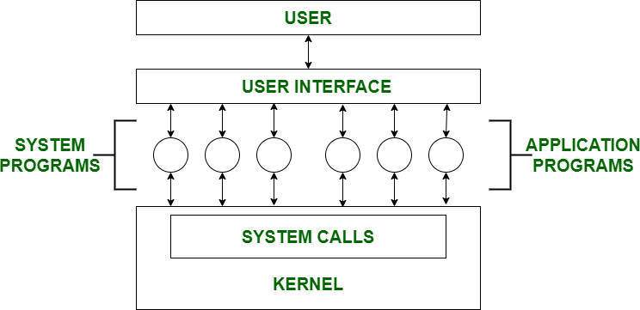

ypes of System programs

The types of system programs are as follows − Utility program

It manages, maintains and controls various computer resources. Utility programs are comparatively technical and are targeted for the users with solid technical knowledge.

Few examples of utility programs are: antivirus software, backup software and disk tools.

Device drivers

It controls the particular device connected to a computer system. Device drivers basically act as a translator between the operating system and device connected to the system.

**Example** − printer driver, scanner driver, storage device driver etc. Directory reporting tools

These tools are required in an operation system to have some software to facilitate the navigation through the computer system.

**Example** − dir, ls, Windows Explorer etc.

Here are the examples of System Programs :

1. **File Management** : A file is a collection of specific information stored in the memory of a computer system. File management is defined as the process of manipulating files in the computer system, its management includes the process of creating, modifying and deleting files.
2. **Command Line Interface(CLI’s) :** CLIs is the essential tool for user . It provide user facility to write commands directly to the system for performing any operation . It is a text-based way to interact with operating system. CLIs can perform many tasks like file manipulation, system configuration and etc.
3. **Device drivers :** Device drivers work as a simple translator for OS and devices . Basically it act as an intermediatory between the OS and devices and provide facility to both OS and devices to understand each other’s language so that they can work together efficiently without interrupt.
4. **Status Information** : Information like date, time amount of available memory, or disk space is asked by some users. Others providing detailed performance, logging, and debugging information which is more complex. All this information is formatted and displayed on output devices or printed. Terminal or other output devices or files or a window of GUI is used for showing the output of programs.
5. **File Modification :** This is used for modifying the content of files. Files stored on disks or other storage devices, we use different types of editors. For searching contents of files or perform transformations of files we use special commands.
6. **Programming-Language support :** For common programming languages, we use Compilers, Assemblers, Debuggers, and interpreters which are already provided to users. It provides all support to users. We can run any programming language. All important languages are provided.
7. **Program Loading and Execution :** When the program is ready after Assembling and compilation, it must be loaded into memory for execution. A loader is part of an operating system that is responsible for loading programs and libraries. It is one of the essential stages for starting a program. Loaders, relocatable loaders, linkage editors, and Overlay loaders are provided by the system.
8. **Communications :** Connections among processes, users, and computer systems are provided by programs. Users can send messages to another user on their screen, User can send e-mail, browsing on web pages, remote login, the transformation of files from one user to another.

**Protection and Security in Operating System**

Protection and security requires that computer resources such as **CPU**, **softwares**, **memory** etc. are protected. This extends to the operating system as well as the data in the system. This

can be done by ensuring integrity, confidentiality and availability in the operating system. The system must be protect against unauthorized access, viruses, worms etc.

Threats to Protection and Security

A threat is a program that is malicious in nature and leads to harmful effects for the system. Some of the common threats that occur in a system are −

Virus

Viruses are generally small snippets of code embedded in a system. They are very dangerous and can corrupt files, destroy data, crash systems etc. They can also spread further by replicating themselves as required.

Trojan Horse

A trojan horse can secretly access the login details of a system. Then a malicious user can use these to enter the system as a harmless being and wreak havoc.

Trap Door

A trap door is a security breach that may be present in a system without the knowledge of the users. It can be exploited to harm the data or files in a system by malicious people.

Worm

A worm can destroy a system by using its resources to extreme levels. It can generate multiple copies which claim all the resources and don't allow any other processes to access them. A worm can shut down a whole network in this way.

Denial of Service

These type of attacks do not allow the legitimate users to access a system. It overwhelms the system with requests so it is overwhelmed and cannot work properly for other user.



Protection and Security Methods

The different methods that may provide protect and security for different computer systems are −

Authentication

This deals with identifying each user in the system and making sure they are who they claim to be. The operating system makes sure that all the users are authenticated before they access the system. The different ways to make sure that the users are authentic are:

# Username/ Password

Each user has a distinct username and password combination and they need to enter it correctly before they can access the system.

# User Key/ User Card

The users need to punch a card into the card slot or use they individual key on a keypad to access the system.

# User Attribute Identification

Different user attribute identifications that can be used are fingerprint, eye retina etc. These are unique for each user and are compared with the existing samples in the database. The user can only access the system if there is a match.

One Time Password

These passwords provide a lot of security for authentication purposes. A one time password can be generated exclusively for a login every time a user wants to enter the system. It cannot be used more than once. The various ways a one time password can be implemented are −

# Random Numbers

The system can ask for numbers that correspond to alphabets that are pre arranged. This combination can be changed each time a login is required.

# Secret Key

A hardware device can create a secret key related to the user id for login. This key can change each time.